**Evidence for a Scale Invariant Relationship Between the Incumbency Advantage and the Nationalization of U.S. House Elections 1866–2014**

Brad L. LeVeck[1], University of California, Merced, CA, USA, 95343

Stephanie A. Nail, University of California, Merced, CA, USA, 95343

**Abstract**: In a recent article, Jacobson (2015) examines the rise and fall of the incumbency advantage from 1952 to 2014. He shows that the incumbency advantage over this period rose as elections became more localized, and has fallen in recent decades as elections have become more nationalized. In this research note, we examine whether a similar relationship holds when we extend the time-series back to the end of the Civil War. Consistent with earlier work, we find that the scale of the incumbency advantage was much smaller in the period prior to 1952— approximately ranging between 0 and 4 points. However, despite this difference in scale, there remains a very similar negative correlation between the nationalization of elections and the incumbency advantage. We therefore speculate that the nationalization of elections diminishes the relative size of the incumbency advantage, but the overall size of that advantage may also be shaped by other factors, such as technology, institutional reforms, or changes in the media landscape.

**Keywords:** incumbency advantage, nationalization, congressional elections

**Introduction**

In a recent article, Jacobson (2015) shows that the rise and decline of the incumbency advantage from 1952 to 2014 closely coincided with the de-nationalization and subsequent re-nationalization of U.S. House elections. According to Jacobson’s theory, when voters’ decisions become decoupled from their evaluations of the national parties—as appeared to happen in the 1960’s and 70’s—incumbents find it easier to cultivate the “personal vote” in their district (Ansolabehere, Snyder, and Stewart 2000; Fenno 1977; Fiorina 1989; Mayhew 1974; Parker and Davidson 1979). However, in recent decades, voters have increasingly cast their ballots on the basis of national factors—such as the ideological reputation of the national parties (Cox and McCubbins 2007; Kim and LeVeck 2013; Snyder and Ting 2003; Woon and Pope 2008), or, on the parties’ performance in Congress (D. R. Jones 2010). Unfortunately, from the perspective of many House incumbents, this resurgence in nationalized voting has diminished their ability to “develop, through their own locally focused efforts, a personal relationship with constituents that can insulate them from national partisan forces” (Jacobson 2015, 868).

In this research note, we extend Jacobson’s research by examining whether a similar negative correlation—between the nationalization of elections and the incumbency advantage—also existed in previous eras, going back to the end of the Civil War. While a large number of studies have examined both the nationalization of U.S. House elections[2] and the incumbency advantage[3] prior to WWII, we believe we are the first to examine whether there is a similar relationship between these two variables before and after WWII.

Consistent with earlier work, we find that the scale of the incumbency advantage was much smaller in the period prior to 1952— approximately ranging between 0 and 4 points (Carson, Engstrom, and Roberts 2007; Gelman and King 1990). However, despite this difference in scale, there remains a very similar negative correlation between the nationalization of elections and the incumbency advantage. We therefore speculate that the nationalization of elections consistently diminishes the relative size of the incumbency advantage, but the absolute size of the incumbency advantage may also be independently shaped by other factors.

**Methods and Results**

**Data**

To extend Jacobson’s original dataset, we gathered data on every U.S. House of Representatives election in every state from 1866 to 1944 using the CQ Press Voting and Elections Collection. We restrict our analysis to contested elections where the democratic vote share is greater than 0 and less than 100. We also omitted off-year “special elections”, such as elections held due to a House member’s death. Because both our measures (described below) make intra-year comparisons for each district, we do not include years following congressional re-districting.[4]

**Measuring Nationalization**

Jacobson (2015) measures the nationalization of elections using the correlation between the district-level two-party vote-share for both congressional and presidential races. Here, we use a different measure that is more readily available for the entire time-period: the variance in the district-level two-party vote-swing. This measure was originally proposed by Kawato (1987), and, as we note below is highly correlated with Jacobson’s measure.

According to Kawato (1987), when districts are highly coordinated by national forces—such as changes in congressional performance (D. R. Jones 2010), or national changes in voter sentiment towards either party’s ideology (Erikson, Mackuen, and Stimson 2002)—vote swings across districts will be highly uniform, and the variance in vote swings will be fairly low. By contrast, the variance in vote-swings will be larger if more voters cast their ballot on the basis of local factors that are independent of national-level changes—such as changes in a specific incumbent’s voting record (Ansolabehere and P. E. Jones 2010; Canes-Wrone, Brady, and Cogan 2002; Carson et al. 2010), or an influx of district pork that offsets an unfavorable party reputation (Carroll and Kim 2010).[5]

Because raw variances can be hard to interpret, and because they can over-weight outliers, we use the standard deviation in the district vote swing (rather than the variance).[6] To make our measure directly represent relative increases in nationalization (rather than relative decreases), we add a negative sign to the measure. Our measure of *nationalization* is therefore , where  is the democratic vote-share for district *i* in year *t*. [7]

Figure 1a plots our measure of nationalization for every year from 1866 to 2014, and shows two notable features. First, our measure recapitulates Jacobson’s finding that elections became less nationalized from 1954 through the mid 70’s (2015). They then became increasingly nationalized, with 2014 being the most nationalized election since the end of the Civil War. Given that our measure picks up the same trend noted by Jacobson (2015), it is perhaps unsurprising that our measure is highly correlated with Jacobson’s measure during the time-period where both measures are available (*r* = .79, *p* < 2.39 × 10 -6). Second, there is also significant variation in the level of nationalization prior to 1952, with the least nationalized year occurring in 1878.

**Measuring the Incumbency Advantage**

We use the Gelman-King measure of the incumbency advantage (1990). This is the electoral advantage received by incumbents after controlling for the two-party vote-share in the previous election and the winning party in a congressional race. Technical details about this measure can be found in the Online Appendix.

Figure 1b plots the incumbency advantage in every year since the Civil War. Similar to prior works (Carson, Engstrom, and Roberts 2007; Gelman and King 1990), we find that the incumbency advantage was much smaller in the era prior to 1952 (where Jacobson’s analysis starts), ranging from 0 (or effects that are not statistically distinguishable from 0) to about 4 points (which is about 1/3 the maximum effect, recorded in 1974).

**Figure 1:** The Relationship Between the Incumbency Advantage and the Nationalization of Elections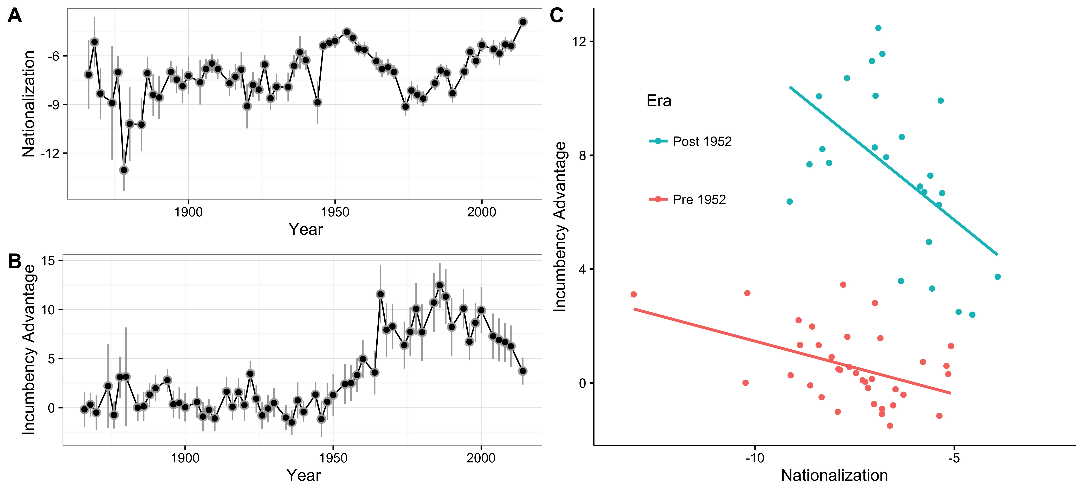

**Nationalization and the Incumbency Advantage**

Figure 1c illustrates our main finding regarding the relationship between nationalization and the incumbency advantage using a scatterplot, with a separate linear trend line for elections before and after 1952. There is a notable, vertical shift in the time-series between the years 1950 and 1954, which corresponds to the well-known finding that the incumbency advantage grew significantly starting in the 1950’s (Gelman and King 1990). However, despite this shift, it is also clear that there is a very similar, negative relationship between the two variables (-.54 post 1952 vs. -.46 pre 1952), and we cannot reject the hypothesis that these two correlations are the same (*p* = .397).

There are two worries that one might have about this finding. First, one might worry that the pre 1952 result is driven by the 1878 election, which, with a nationalization score of -13, is a clear outlier in both panel 1a and 1c. However, a similar result holds if we remove this year (*r* = -0.34*, p* = .049). The result also holds if we use the Spearman rank correlation, which is much less sensitive to outliers (*r =* -0.38*, p* = 0.02). Second, given that the least nationalized years follow the end of reconstruction, one might worry that the result is somehow specific to the South emerging from the Civil War. In the Online Appendix, we show that the result remains the same even if we restrict our analysis to the northern states.

**Discussion**

The aim of this research note is to add a simple, but interesting finding to the literature. Like Jacobson’s study, we cannot claim that the association we find between the nationalization of House elections and the incumbency advantage is necessarily causal. However, our result is consistent with Jacobson’s argument that the nationalization of elections drives the relative size of the incumbency advantage.

However, our finding also sheds new light on Jacobson’s speculation that other factors—such as additional opportunities to provide constituent service or the rise of local media—were “derivative” and did not exert much of an independent effect on the overall size of the incumbency advantage (2015, 868). Contrary to this proposal, our findings show that the nationalization of elections had a fairly consistent effect on the *relative* size of the incumbency advantage from the end of the Civil War to present—even though the *overall* size was dramatically higher after 1952. This suggests that other factors may actually have an independent effect on the baseline level of the incumbency advantage, while changes in the nationalization of elections affect its relative size. For example, the emergence of local media after 1952 might have improved incumbents’ ability to advertise their individual accomplishments (Prior 2006). Meanwhile, the relative size of this new advantage may have still been tempered by voters’ propensity vote on local factors (like incumbents’ individual accomplishments) instead of more national factors, such as national party brands.

**Bibliography**

Ansolabehere, Stephen, and Philip Edward Jones. 2010. “Constituents’ Responses to Congressional Roll-Call Voting.” *American Journal of Political Science* 54(3): 583–597.

Ansolabehere, Stephen, James M. Snyder, and Charles Stewart. 2000. “Old Voters, New Voters, and the Personal Vote: Using Redistricting to Measure the Incumbency Advantage.” *American Journal of Political Science* 44(1): 17–34.

Canes-Wrone, Brandice, David W Brady, and John F Cogan. 2002. “Out of Step, Out of Office: Electoral Accountability and House Members' Voting.” *American Political Science Review* 96(01): 127–140.

Carroll, Royce, and Henry A Kim. 2010. “Party Government and the ‘Cohesive Power of Public Plunder’.” *American Journal of Political Science* 54(1): 34–44.

Carson, Jamie L et al. 2010. “The Electoral Costs of Party Loyalty in Congress.” *American Journal of Political Science* 54(3): 598–616.

Carson, Jamie L, Erik J Engstrom, and Jason M Roberts. 2007. “Candidate Quality, the Personal Vote, and the Incumbency Advantage in Congress.” *American Political Science Review* 101(02): 289–301.

Claggett, William, William Flanigan, and Nancy Zingale. 1984. “Nationalization of the American Electorate.” *American Political Science Review* 78(1): 77.

Cox, Gary W., and Mathew D. McCubbins. 2007. *Legislative Leviathan*. Cambridge University Press.

Eagles, Charles W. 2010. *Democracy Delayed*. University of Georgia Press.

Erikson, Robert S., Michael B Mackuen, and James A Stimson. 2002. *The Macro Polity*. Cambridge University Press.

Fenno, Richard F. 1977. “U.S. House Members in Their Constituencies: An Exploration.” *American Political Science Review* 71(03): 883–917.

Fiorina, Morris P. 1989. 1–169 *Congress, Keystone of the Washington Establishment*. Yale University Press.

Gelman, Andrew, and Gary King. 1990. “Estimating Incumbency Advantage without Bias.” *American Journal of Political Science* 34(4): 1142–1164.

Jacobson, Gary C. 2015. “It’s Nothing Personal: The Decline of the Incumbency Advantage in US House Elections.” *Journal of Politics* 77(3): 861–873.

Jones, David R. 2010. “Partisan Polarization and Congressional Accountability in House Elections.” *American Journal of Political Science* 54(2): 323–337.

Kawato, Sadafumi. 1987. “Nationalization and Partisan Realignment in Congressional Elections.” *American Political Science Review* 81(4): 1235.

Kim, Henry A, and Brad L LeVeck. 2013. “Money, Reputation, and Incumbency in U.S. House Elections, or Why Marginals Have Become More Expensive.” 107(03): 492–504.

Mayhew, David R. 1974. *Congress*. Yale University Press.

Parker, Glenn R, and Roger H Davidson. 1979. “Why Do Americans Love Their Congressmen so Much More than Their Congress?.” *Legislative Studies Quarterly* 4(1): 53.

Prior, Markus. 2006. “The Incumbent in the Living Room: The Rise of Television and the Incumbency Advantage in U.S. House Elections.” *Journal of Politics* 68(3): 657–673.

Snyder, James M., and Michael M. Ting. 2003. “Roll Calls, Party Labels, and Elections.” *Political Analysis* 11(4): 419–444.

Woon, Jonathan, and Jeremy C Pope. 2008. “Made in Congress? Testing the Electoral Implications of Party Ideological Brand Names.” *Journal of Politics* 70(03).

1. Corresponding author: [bleveck@ucmerced.edu](mailto:bleveck@ucmerced.edu), University of California, Merced 5200, North Lake Road, Merced, CA 95343
2. E.g. Kawato (1987); Clagget, Flanigan, and Zingale (1984)
3. E.g. Carson et al. (2007); Gelman and King (1990); Ansolabehere, Snyder, and Stewart (2000)
4. In general, this is years ending in 2. The one exception is 1922, when redistricting did not occur (Eagles 2010).
5. In line with Jacobson’s conceptualization, Kawato’s measure is really about nationalization with respect to parties’ electoral outcomes. For example, a purely anti-incumbent swing could produce highly variable swings in the Democratic vote-share.
6. However, this does not fundamentally changes our results or conclusions. In fact, our results are slightly stronger if we use the raw variances proposed by Kawato (1987).
7. Again, we omit elections where year *t* follows redistricting (e.g. 1972) because districts in this year are not comparable to districts in year *t* – 2 (e.g. 1970).